1. Creating and Renaming Files/Directories.
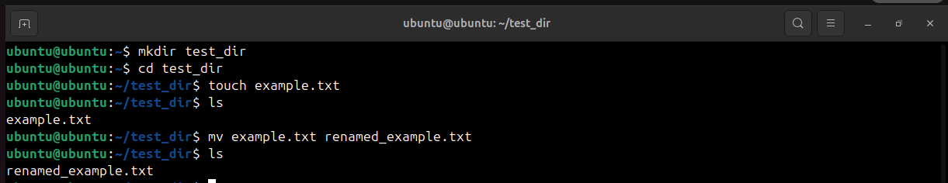
mkdir – This Command is used to create directories in Linux
cd – This Command is used to navigate through Directories
touch – Used to create blank/empty Files
ls – This command helps to list directories and files in directories
mv – This Command is used to move or rename files in Linux

2. Viewing File Contents.

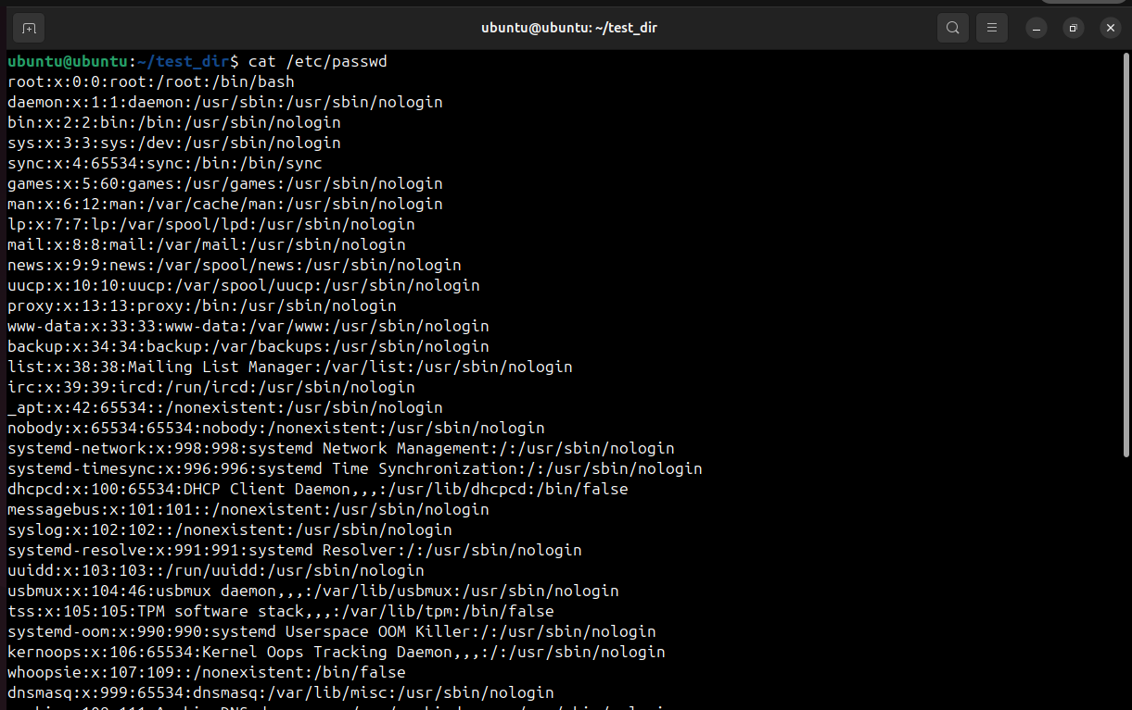
cat – Display File Contents on terminal.

Head – This command will output the first 5 lines of the /etc/passwd file in the terminal.
Tail – This command will output the last 5 lines of the /etc/passwd file in the terminal.

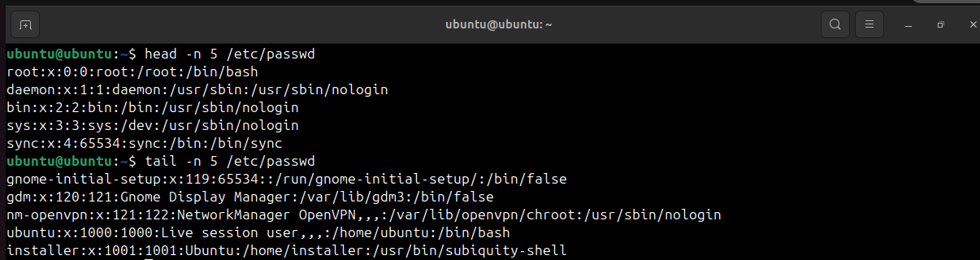
3. Searching for Patterns.

grep – This is the command-line utility used for searching plain-text data sets for lines matching a
regular expression.
“root” – This is the search pattern. Grep will look for lines that contain this exact string.
/etc/passwd – This is the path to the file that grep will search whitin.
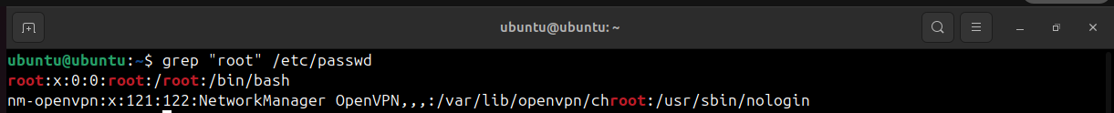
4. Zipping and Unzipping.

Zip – This is the command which is used for creating and manipulating zip archives.
-r – This option stands for “recursive”. It tells zip to include all files and subdirectories within the
test_dir directory in the archive. (without this option, only the test_dir directory itself [as an
empty directory] would be zipped).
test_dir.zip – This is the name which we want to give to the output zip archives file.
test_dir – This is the directory which we want to compress.

Unzip – This is the command-line utility for extracting files from a zip archive.
test_dir.zip – This is the name of the zip archive we want to extract.
-d unzipped_dir – This option specifies the destination directory where the contents of the zip file
will be extracted. If the directory unzipped_dir does not exist, uzip will create it.
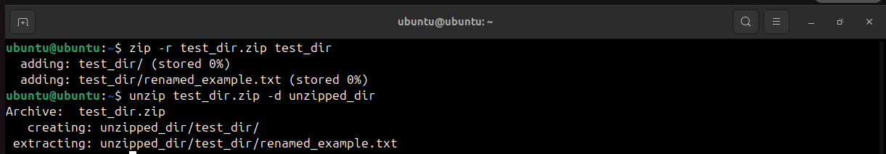

5. Downloading Files.

Wget – This command-line is used for Downloading files from the Internet.
https://en.wikipedia.org/wiki/Tom_and_Jerry – This is the URL (Uniform Resource Locator) of
the file which we used to download.
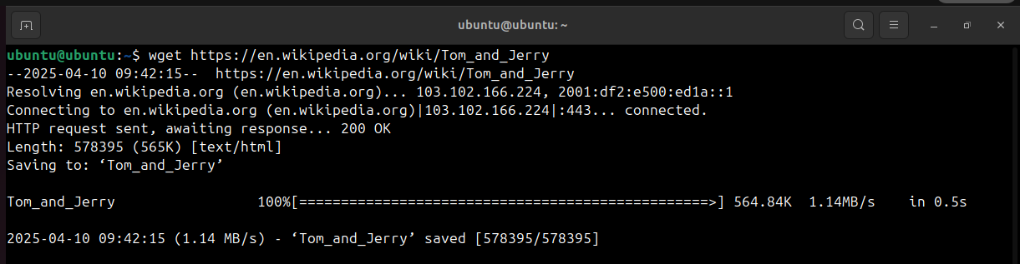
6. Changing Permission.

touch – This command is used to create an empty file.
chmod – This is the command-line utility used to change file permission.
a - This Represents “all” users (Owner,Group,Others)
w - This removes the “write” permission.
secure.txt – This is the name of the file whose permission we are modifying.
444 – This is the Numeric representation of the permission. The three digits represent the
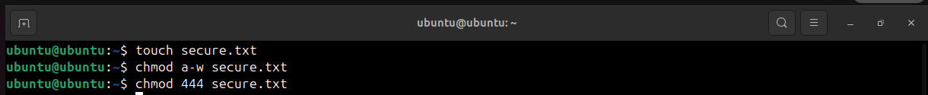
permission for owner,group and others

7. Working with Environment Variables.

Export – This is a command used to set environment variables.
MY_VAR – This is the name we have assigned to the new environment vairable.
= : The equal sign is used to assign a value to the variable.
“Hello,Linux!” – This is the value which was assigned to the MY_VAR environment vairable.
(Double quotes are used because the value contains a space)

